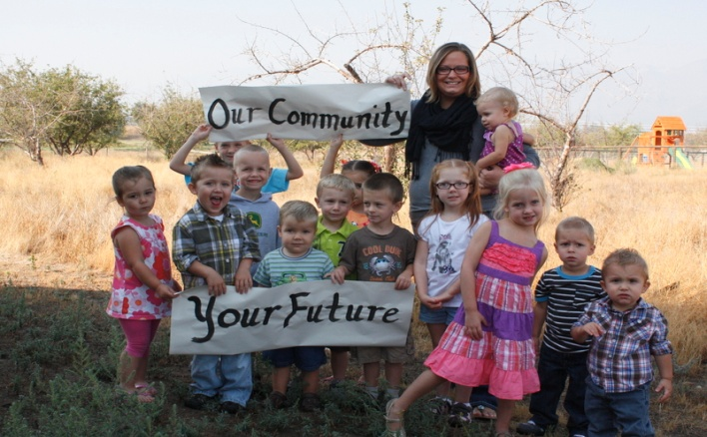
Ravalli’ County’s health and prosperity depends on our ability to ensure that all children have the opportunity to thrive. Children who group in a supportive environment where their health, safety and education needs are priorities, have a solid foundation for a happy and productive futures.

123 Invest in Me! A Best Beginning Community Council conducted a needs assessment as a first step to assess the state of children in Ravalli County. This information was compiled from multiple sources pulled together to document the state of children in Ravalli County as shown by the numbers.
Key Findings
- Almost 39% of children under the age of 5 live below the poverty line.
- 13% of Ravalli Families using Supplemental Nutrition Assistance Program were also on Temporary Assistance for Needy Families.
- In 2012 270 children were eligible for Head Start, but funding only allowed them to serve 132 children.
- Ravalli County is designated as a Health Professional Shortage Area for dental and primary care health.
- Pantry Partners reported in 2011 that they had an increase of 37.3 % from 2007 of families receiving goods.
- Limited public transportation, cost prohibited.
- No homeless shelter
Demographics of Children 0-5 and Families
- Children under the age of 5 account for 5.3% of Ravalli County’s total population.
- Children under the age of 5 account for 24.3% of Ravalli County’s total population of Children.
- In 2010 there were 2,147 children under the age of 5.
- Female workers in Ravalli County make $.66 for each $1.00 earned by their male counterparts.
- 48.4% of renter-occupied households spend more than 30% of their income on housing.
- The median household income for Ravalli County as reported in the latest US Census was $43,512.
- Affordable housing is limited in Ravalli County. Out of 12 low-income housing apartments only 3 allow single and family residents.
- In 2009 reported domestic violence rate (per 10,000 women 15-44 years of age) was 239.
- Average wages in 2010
  - US: $46,742
  - MT: $34,589
  - Ravalli County: $29,855

US Census Bureau, Poverty Status in the Past 12 Months by Sex by Age- 2006-2010 American Community Survey 5-year Estimates for Ravalli County.
Percentage derived from calculations by report author
Ravalli Head Start Community Assessment (2012). Abbreviated Project Description, July 2012 to July 2013p.4
Data for Community Health Assessment Report for Ravalli County
US Census Bureau, Profile of General Population and Housing Characteristics:2010
US Census Bureau, Profile of General Population and Housing Characteristics:2010
US Census Bureau, USA Counties-General Profile for Ravalli County
US Census Selected Economic Characteristics-2006-2012 American Community Survey 5-year Estimates.
US Census Selected Economic Characteristics-2008-2010 American Community Survey 3-year Estimates.
US Census Bureau, State and County Quick Facts
Report prepared by Maternal and Child Health Epidemiology Unit of the MT Department of Public Health and Human Services, Maternial, Infant, and Early Childhood Home Visiting Risk Indicators.
Montana County Fliers (Feb.2012). Montana Department of Labor and Industry. p. 7.

